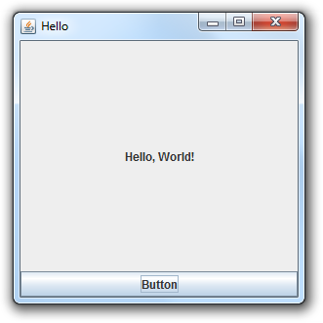Final CPT Program Requirements

* All programs must use Java Swing.
  + Either menus or buttons or text fields somewhere in your program (mixture of animation, buttons, text fields, and or menus).
* All programs must use animation. All programs must use combination of keyboard and mouse inputs. All programs must use file IO. All programs must use socket IO.
* All games must be 1280 x 720 pixels. Restrict the ability to resize frame. All programs must have a chat area.
* All programs must have one or more data files that contain the data for the objects of the game.
  + Example: Fighting game - data files that represent each of the fighters (ex. Holden.txt - Holden’s health, attack, special moves, jpgs)
* Chat functionality. All programs must have a networking protocol (distinguish between game data and chat data).
* Game must include a mixture of buttons and text fields.

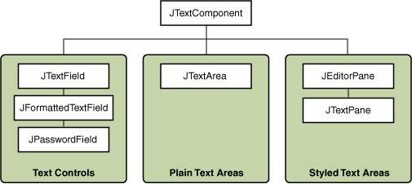

* One window only, JPanel for main menu or swap it out for animation.
* Submitted and updated on GitHub (all team members must update the repository on a regular basis).